**EOSC114 Homework: Extinctions & Impacts** *(See footnote for an important copyright notice[1])*

**Purposes:** This last assignment explores global scale natural “disasters” or hazards, as well as objects that have impacted, or threaten to impact, our planet.

**Goals:** After completing this assignment, you should be able to …

1. compare the times and characteristics of Earth’s five principle extinction events;
2. characterize the relationship between ecosystem diversity and both *extinction* and *origination* **rates**.
3. define “*elevated extinction rates*” by referring to “*background extinction rates*”, then interpret two estimates of “*elevated extinction rates*” for six different animal groups.
4. use the CNEOS website to characterize near earth objects;
5. use the Earth Impact Database to find and describe known craters or crater remnants on Earth.

**Instructions:** Complete the worksheet FIRST before submitting answers online. MC options are randomized so enter choices carefully when transferring worksheet results into Canvas. And recall that this exercise may seem similar to one from previous terms but parameters, question orders, and tasks have been changed. ALSO remember our Class Code of Conduct, and UBC’s strict rules regarding academic integrity.

**Part I: Times of major extinctions and causes, plus observations about the “sixth extinction”.**

* The figure below is a “linear” geological time line presented in a circular format. You may see this or a similar depiction of geological time in class. Seven times are shown with small stars labelled A through G. At which of these times (i.e. which letter‐labels) are each of the “big 5” extinction events?
  + Triassic–Jurassic or Tr‐J. _E__ (201Ma)
  + Permian–Triassic or P‐Tr. _D__
  + Ordovician–Silurian or O‐S. _B__

•

Late Devonian extinction or Late D. __C_

•

Cretaceous–Paleogene or K‐Pg. _F__

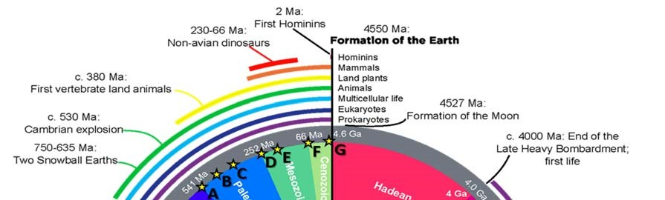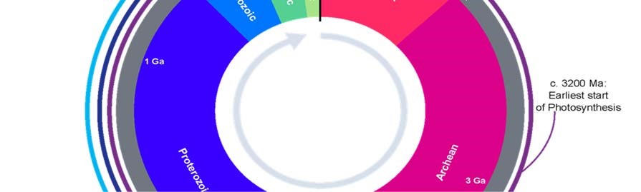

* From this figure, for roughly what proportion of Earth’s entire history has life of any type existed?

a) 3% ‐ 4%, b) 8% ‐ 10%, c) 15% ‐ 20% d) 25% ‐ 30%, e) 45% ‐ 55%, f) 65% ‐ 75%, g) 85% ‐ 95%.

* From this figure, for roughly what proportion of Earth’s entire history have vertebrate land animals existed?

a) 3% ‐ 4%, b) 8% ‐ 10%, c) 15% ‐ 20% d) 25% ‐ 30%, e) 45% ‐ 55%, f) 65% ‐ 75%, g) 85% ‐ 95%.

* From this figure, for roughly what proportion of Earth’s entire history did non‐avian dinosaurs exist on Earth?

a) 3% ‐ 4%, b) 8% ‐ 10%, c) 15% ‐ 20% d) 25% ‐ 30%, e) 45% ‐ 55%, f) 65% ‐ 75%, g) 85% ‐ 95%.

Wikipedia is not always a great resource, but in fact it has good basic coverage of extinctions starting at https://en.wikipedia.org/wiki/Extinction_event. Do not read it all ‐ we will start by using just the data in the table labelled “**List of extinction events**” (Navigate to the Extinctions by severity section and click on the link to the List of extinction events).

* In total, how many extinction events are listed in that table? ____ 33

* What are the most commonly identified possible causes of extinctions? Put these causes into order with “1” being MOST commonly identified and “3” being LEAST commonly identified. (If the possible cause identified in the table is not clear to you look it up – most are linked.)

_3___Impacts or “craters”;

__1__ Changes in sea level, ocean chemistry or anoxia (not including “climate change” without sea‐level changes).

__2__ Volcanic, flood basalt, magmatic provinces or “traps” events.

* What type of evidence is used to identify “extinction events”? HINT: not evidence for how it happened but whether an “extinction event” occurred.
  + Climate records (or proxies for climate variation)
  + The fossil record.
  + Astronomical information such as evidence for supernovae, gamma ray bursts etc.
  + Geological evidence of volcanic events
  + Geological evidence of impactors (asteroid or meteorite collision with Earth)

* How many of all extinction events (Great Oxygenation is not an extinction event) in the table have at least one possible cause identified WITHOUT a reference or citation for that cause? ________ (5)

Read the first four (4) paragraphs under “Causes”, then fill in blanks to complete sentences. Note carefully when authors are discussing *rates* of extinction (or origination) as opposed to *extinction events*.

* Rather than attributing widespread and rapid decrease in the biodiversity to a single cause, at least two types of causes seem to be necessary, each possibly including many factors. First, long‐term pressures on the ecosystem, called by Arens and West 2006 a _____Press__ (one word only), make an eco‐system vulnerable, then a different set of more sudden changes, called a __Pulse ____ (one word only), appears to tip the system into collapse.

Now consider the apparent relationship between ecosystem diversity and the rates at which species either appear or disappear (i.e. rates of origination or extinction).

* Fill blanks with *“increasing”, “decreasing” or “unchanging”:* According to this short section, periods with **more** diverse ecosystems appear to be correlated with Increasing rates at which species **disappear**. Also, periods with **less** diverse ecosystems appear to be correlated with Increasing rates at which species **appear**.

* If the past 100,000 years has seen highly diverse ecosystems, this relationship would predict that the rate at which species (*appear / disappear)* might increase during this period, while the rate at which species (*appear / disappear)* might decrease. Do these predictions appear to be consistent with reality (WITHOUT trying to attribute any causes, whether human or otherwise)? *Yes / no / uncertain.*

* I n those 4 paragraphs, the authors included a total of 4 references, and 4 of those references appear to be peer‐reviewed. Fill blanks with just the number, not words (eg ‘10’, not ‘ten’).

Figures 2a and 2b to the right are from that Wikipedia page, presented here with x‐axes aligned. NOTE: consider what’s shown carefully. One graph shows *the* ***proportion*** *of total marine genera becoming extinct* over time, and the other shows *the total* ***numbers*** *of marine genera* over time.

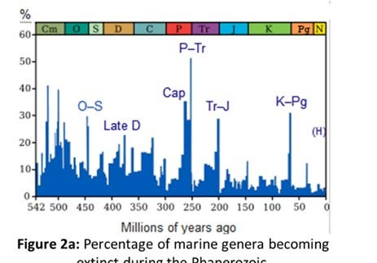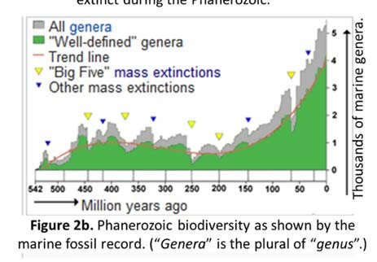

* For which of the big 5 extinction events did the highest relative proportion (i.e. percentage) of marine animal g*enera* (see footnote[2]) become extinct? (Online options will be randomized.)

• O‐S • Late D • P‐Tr • Tr‐J • K‐Pg

* For which of the big 5 extinction events was the total number of *genera* largest just before the extinction?

• O‐S • Late D • P‐Tr • Tr‐J • K‐Pg

* For which of the big 5 extinction events did the lowest relative proportion (i.e. percentage) of marine animal *genera* become extinct?

• O‐S • Late D • P‐Tr • Tr‐J • K‐Pg

* For which of the big 5 extinction events was the total number of *genera* the smallest just before the extinction?

• O‐S • Late D • P‐Tr • Tr‐J • K‐Pg

* What general lesson can be learned from this pair of figures by examining trends rather than the spikes representing extinction events? Earlier in time there seems to have been …
  + …higher diversity, and higher proportions of that diversity suffered in extinctions.
  + …higher diversity, and lower proportions of that diversity suffered in extinctions.
  + …lower diversity, and higher proportions of that diversity suffered in extinctions.
  + …lower diversity, and lower proportions of that diversity suffered in extinctions.

* What general lesson appears to be true regarding extinctions (periods of loss in biodiversity) versus “originations” (periods of gain in biodiversity)?
  + Extinctions and originations both usually seem to occur suddenly.
  + Extinctions and originations both usually seem to occur slowly.
  + Extinctions usually seem to occur slowly while originations usually seem to occur suddenly. • Extinctions usually seem to occur suddenly while originations usually seem to occur slowly.
  + There seems to be no pattern regarding rates at which extinctions or originations occur.

* According to the data we are shown here, our planet suddenly lost well over a third of it’s marine genera __ time(s) since 542 million years ago.

a) 1 b) 2 c) 3 d) 4 e) 5 f) 6 g) 7 h) 8 i) 9 j) 10

**Part II: sixth or Holocene or Anthropocene extinction**

**First some information**: The sixth or Holocene or Anthropocene extinction is the ongoing extinction of species over the past 10,000 years (or 100,000 years depending on point of view) mainly due to human activity. Affirming this notion requires determining whether extinctions are occurring more rapidly now than the average extinction rates observed in the fossil record between major, known mass extinction events.

**Now open the article at** http://advances.sciencemag.org/content/advances/1/5/e1400253.full.pdf[3]. Please study the questions in this part carefully, then focus on the article’s “Table 2”. Read ONLY as much of the article as you need to fill in blanks of questions below. We will NOT ask questions about the whole article.

**HINTS:** *Consider just the first row of Table 2. Four different estimates of elevated vertebrate extinction rates are presented.* ➢ *In the first two columns, the authors give results of using a so‐called “****highly conservative****” model. These results estimate extinction rates of vertebrates to be* ***8*** *times faster than “background” extinction rates[4] since 1500 and* ***22*** *times faster than background since 1900.* ➢ *In the second two columns, they give results of using a different, so‐called “****conservative****” model. These results estimate extinction rates of vertebrates to be* ***15*** *times faster than background since 1500 and* ***53*** *times faster than background since 1900.*

* *Fill blanks with either “higher than”, “lower than”, or “similar to”.* In the abstract, the authors imply that their estimate for average **current** rate of vertebrate species loss over the last century is Higher than the **background** rate. If the authors had used “normal” rather than “conservative” values for current rates of extinction, their result would have been higher than the estimate they gave.

* Regardless of model or time period, it seems that animals in which group Reptiles are going extinct at the “slowest” rate? The animal group with the single most alarming elevated extinction rate is

Amphibian , determined using the conservative model and considering extinctions since the year 1900. Using the **highly conservative** model, the animal group with the most elevated rate of extinction seems to be mammals while the **conservative** model suggests that Amphibians have the most elevated rate of extinction.

◻One point of the article is to identify that, regardless of time period or model used, all these animal groups have been observed to be experiencing extinction rates that are much more than background extinction rates.

* + Much less than
  + Slightly less than
  + Similar to
  + Slightly more than • Much more than

* The conclusion is illustrated in a third way by showing the proportion of all animals in each group that have gone extinct since 1500, estimated using the two models. This is shown in

• Table 1 • Table 2 • Figure 1 • Figure 2 • within the text only.

What goes into generating estimates and drawing conclusions like this? Is this an “easy” job? Fill in each of these blanks with just a number. No words – just **one number** for each blank.

* The research was clearly a “team effort” as the article (published in the year 2015) has 6 authors, representing a total of __ departments in __ different institutions from __ different countries (see footnote of page 1). As evidence of the extensive precedent underlying this work there were __ references or notes, with __ of these each having well over 50 contributing authors, and some details were provided as “supplementary materials” consisting of __ additional tables.

**Part III:** Next we consider just one of the possible contributors to mass extinctions; meteor or asteroid impacts.

* NASA’s website for their **Center for Near Earth Object Studies** (CNEOS) starts at http://cneos.jpl.nasa.gov/. First, to ensure you understand terminology, find the glossary under the “Extras” menu and match the following terms to these definitions:

|  |  |
| --- | --- |
| **Term** | **Definition** |
| LD = e | a) absolute visual magnitude (which, counterintuitively, is a *smaller* value for *larger* objects) |
| Au = d | b) a measure of the proportion of light reflected off a surface |
| H = a | c) any object that will pass near Earth |
| PHA = f | d) average distance between Earth and Sun |
| NEO = c | e) average separation between Earth and Moon |
| Albedo = b | f) an asteroid deemed to be possibly dangerous |

Now we will use the CNEOS data set to explore anticipated dates and closest approach distances of large NEOs.

Find the “NEO’s” item under the “Close Approaches” menu.

* Before doing anything else, look at the table on this page. It has 8 column headings. Which column is currently being used to sort the rows? CA Date.

Let us use this database to find the ***largest object*** *that has passed near Earth* ***closer than the moon in the past***.

Do this by setting the three “**Table Settings:”** using their drop‐down boxes to:

‐ FIRST, set “no H limit” – wait for “processing” to finish and the table to change,

‐ SECOND, set “Nominal dist. <=1LD” – wait for table to change,

‐ THIRD set “**Past only**”

Also, select **Show 25 entries** in the dropdown just under Table Settings. Finally, click the “**Estimated Diameter**” column heading once to sort the table in order from largest to smallest diameter of NEO’s, constrained by the three Table Settings.

Is the top object designated as “*458732 (2011 MD5)*”? If not, reload the page in your browser, then click through the settings again, one at a time allowing the table to update before setting each new parameter.

* What is the date of nearest approach to Earth for this *largest object in the past*, its size and the distance of this object from Earth at it’s closest approach?

Year 1918 , month Sep -17 (name not number); estimated minimum distance from Earth at its closest approach, first in units of LD 0.910 (not in ‘au’ units). Also convert this to kilometers using a value of LD=384,400km: 349,804 km.

* What was this objects diameter in km? Average the minimum and maximum “Estimated Diameter”. 1.165 km (watch your units).
* NEOs that are estimated to be equal to or larger than 140m diameter are considered to be potentially hazardous[5]. Based on the list in front of you (considering *maximum* estimated diameter), how many of these

"potentially hazardous" objects are known to have passed by Earth closer than the moon in the past? 13 .

(Hint: if it’s more than 25, reload the page, and reset the parameters one at a time slowly.)

* Given the frequency‐magnitude plot below, what is the minimum expected return period in years for impactors of at least 140m diameter? Read this log‐log graph carefully! ___ years.

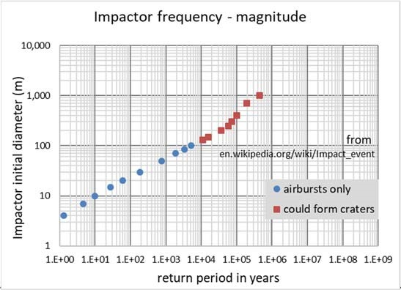

Figure 3, derived from data at en.wikipedia.org/wiki/Impact_event

* Now use the sorting capability of this table to find the object that is predicted to have the closest NOMINAL approach to earth of all these entries (don’t change parameters, just sort the current table). What is the distance of closest approach for this object IN KILOMETERS? 0.018 =6919.2 km. NOTE: 1 LD = 384,400km.

You are now in a position to offer advice. Two issues are (1) could this object have threatened satellites in geosynchronous orbit around Earth (which is at roughly 35,000km), and (2) could it have been considered “possibly hazardous” to Earth? No, No

* Would this object having the closest NOMINAL approach have threatened geosynchronous satellites?
  + The object’s Closest Approach estimate does make it a possible threat, AND it is big enough to potentially damage a satellite.
  + Given this object’s Closest Approach estimate, it is not a threat to geosynchronous satellites, regardless

of it’s size.

* + The object’s Closest Approach estimate does make it a possible threat, but it is not big enough to potentially damage a satellite.
  + Not enough information to make this judgement.
* If this Close‐Approach estimate was in error by up to 15,000 km, might this object have been “possibly hazardous” to Earth?
  + The object will not come close enough to be a threat to Earth, even given this error in Close‐Approach estimate.
  + The object could come close enough AND it is big enough to be “possibly hazardous” to Earth.
  + The object could come close enough to be a threat, but is not big enough to be “possibly hazardous” to Earth.
  + Not enough information to make this judgement.

* We should of course be careful to understand the uncertainty in these data. Click the “reasonably low uncertainty” link in this page’s introductory paragraph and answer the following: Of several parameters contributing to uncertainty, which is most significant? • number of observations or measurements;
  + amount of time spent making by those observations
  + quality of the observations (e.g. radar vs optical)
  + geometry of the observations

Next we ask – have all “hazardous” objects been detected? No, not yet, however, we can determine whether ongoing searches are still finding objects. To learn more, go to the “Introduction” item in the CNEOS website’s “Discovery Statistics” menu.

* From the paragraph 1 on that page, the NEO program estimates that they have already found over 90% of …
  + all NEOs
  + NEOs larger than 140 m in diameter
  + NEOs larger than 1km in diameter
  + all NEOs with albedos greater than 20%
  + all visible NEOs

The counts of NEO discoveries by year are summarized via links (buttons) along the top of this “Discovery Stats” Introduction page. First click the “**by Survey (km)**” button; you should see a graph that looks the one sketched to the left. (*HINT: find values requested by moving your mouse over the graph (no clicking) to see information about data under the mouse pointer.*)

* Now fill blanks with numbers only (no decimal places, no words). The largest number of large (> 1km diameter) NEOs was found in the year 2000 in which a **total** of 80 large NEOs were found. In subsequent years, counts of large NEO discoveries declined, and in the year 2016, a **total** of only 8 were found.
* Now, on the “**by Survey (140m)**” page, we can see that the largest count of newly discovered NEOs 140m or larger was in the year 2016 in which a total of 546 new NEOs in that size range were found. In comparison, the total number of NEOs in this size range discovered in, for example, the year 2000, was 307
* Based on these observations, it appears as if
  + most of both large (>1km) and moderate (>140m) NEOs have already been found.
  + most of the large (>1km) NEOs have been found, but there are many moderate (>140m) NEOs still to be found.
  + there are many large (>1km) NEOs still to be found, but most of the moderate (>140m) NEOs have been found.
  + there are many large (>1km) and moderate (>140m) NEOs still to be found.

**Part IV:** We now want to consider existing evidence for impacts on our planet. We will use the Earth Impact

Database maintained by the **Planetary and Space Science Centre** at the University of New Brunswick,

Fredericton, New Brunswick, Canada. Go to http://www.passc.net/AboutUs/index.html and click on “**Earth Impact Database**” in the left‐hand menu.

* From “About …” paragraphs, how many confirmed impact structures are in the whole database? 190
* All of the following are reasons that contribute to why we see so few craters on Earth compared to the moon or other solar‐system bodies. However, which one do you think is less important than all the others? Just think logically; there is no need to read anything further to answer.
  + We have not yet been able to examine the entire surface with sufficient detail.
  + Plate tectonics has “recycled” a large portion of surface materials.
  + Much of Earth’s surface has been eroded.
  + Much of the surface is masked by vegetation and the accumulated soil it grows in.
  + Oceans are both covered in water and relatively “young” compared to continental materials.

This database can be viewed on the website with data sorted in one of three ways; by name, age or size. To answer the following, use these sorting options, found in the “Sorted by:” link, right hand end of the menu.

* How many impact structures, not including unknowns, are LESS than 10,000 years old? 13 .
* Given this value, what is the average time between impacts for these impactors? Approximately 769.23 years between impactors in the last 10,000 yrs.
* Using the same approach, what is the average time between impacts based on only those impactors that are less than 1000 years old? Approximately 200 years between impactors in the last 1,000 yrs. 1000 / 5
* Given these average times between impacts estimated over different time spans, which of these statements is most likely to be correct?
  + Time between impacts of impactors appears to be fairly constant.
  + More impactors have been hitting Earth recently than in the more distant past.
  + Fewer impactors have been hitting Earth recently than in the more distant past.
  + More impactors appear to be hitting Earth recently, but the estimates vary because older craters are harder to detect.
  + Fewer impactors appear to be hitting Earth recently, but the estimates vary because older craters are harder to detect.
* How many impact structures do we know of that are 1 billion or more years old? 15.
* How many impact structures are 100 metres or less in diameter? 11.

Click on the “**| North America |**” link to obtain an embedded Google Map with map markers for known impact craters on our continent. Find the one closest to the city of Edmonton in the Province of Alberta and click on it. You will need to zoom into the map to see city names. You will be given a panel of details on the left of the map. Find the “Crater Name” in that panel, find the same entry in the table below the map, and click the name for a page of details. NOTE the links in the map panel do not work, but links in the table are good.

* The crater is named Whitecourt. It is 40 meters in diameter, less than 1100 years (not

Ma) old and there are 1 references that you could pursue if you were interested.

* Regarding the crater closest to Edmonton, in which type of image is this crater most obvious? (Click blue/red dots on the image to see different illustrations.)
  + Photograph taken in summer
  + Photograph taken in fall
  + LiDAR image taken showing full features
  + LiDAR image taken showing bare‐earth features

Click on the “World Map” link and consider the image of the world with dots for all known impacts. Consider that only abut 15% of all these are less than a million years old.

* What is the most likely reason why there are so many known impacts in Australia?
  1. That region must have been left largely undisturbed by tectonic activity like mountain building and subduction.
  2. The surface of that region is disrupted and hidden by very active biological activity.
  3. That region has been disturbed by tectonic activity like mountain building and subduction.
  4. That region is essentially invisible from satellite imaging systems.
  5. That region is rather unpopulated.
* What is the most likely reason why there are so few known impacts in equatorial South America and Africa? (Same options)

1. This worksheet copyright © 2019, F. Jones, L. Porritt and UBC. All rights reserved. Re‐distribution to anyone or the web is against copyright law. See UBC intellectual property rights at https://copyright.ubc.ca/guidelines‐and‐resources/faq/.
2. “*Genera*” is the plural of “*genus*”, and most *genera* include several *species*.
3. G. Ceballos, P. R. Ehrlich, A. D. Barnosky, A. García, R. M. Pringle, T. M. Palmer. *Accelerated modern human–induced species losses: Entering the sixth mass extinction*. Sci. Adv. 1, e1400253 (2015).
4. The “**background extinction rate**” represents the number of species dying off over a period of time that does NOT include a

   “mass extinction”. This represents an undisturbed or steady state, with some species going extinct while others emerge.
5. See NEO Basics page (under “About”), although this is NOT necessary reading here.